GREAT MARLOW SCHOOL BOAT CLUB

SAFETY AND BOATING PLAN
2017/18

Guide to the policies and documents
Introduction
This includes an introduction to the club structure and individuals roles and responsibilities. It outlines the committee’s roles in supporting the Boat Club and contains the definitions of any key words used throughout these documents.
- Club structure
- Great Marlow Swans Supporters Group
- Roles
- Current Officials within the Club
- Responsibilities
- Location of sessions
- Definitions
Requirements before any individual may row
These requirements apply to any rower, parent or coach who wishes to use the facilities offered by the club. This includes:
- The capsize drill
- First aid and safety within the club
- The Boat Club rules, contract and code of conduct
- The membership form
Club equipment and repairs
Anyone wishing to use the Boat Club facilities must understand that good maintenance of our equipment is crucial and that it is everyone’s responsibility.
Coaching
All coaches, whether paid or volunteer, have to follow strict guidelines on conduct and safety.
- Coaches code of conduct
- Volunteer coaches guide

Safety procedures for the river
As a club it is essential that these documents are kept up to date and reviewed regularly
- Safety noticeboard
- Incident report book
- Before and during boating
- Navigation on a normal stream
- Navigation on a strong stream
- Night/after dark and rowing in fog
- Lightning
- Risk assessment for Longridge and The River
- Racing
- Rules of racing
A map of the river
This map of the river shows the stretch between Marlow Lock and Cookham Lock. All river training is done between these two points.
- Main points of interest
- Rescue/drop off points
- Turning points on the stretch
Rowsafe: A guide to good practice in rowing
Published by British Rowing, Row Safe replaces the third revision of the Water Safety Code, published in 2003. The new guidance presents information under five headings, each with separate topic areas following the same format:
- Responsibilities
- Minimum standards
- Further good practice
- Further information
Welfare documents
- Safeguarding and protecting children policy
- Guidance for Safer Working Practice for Adults who work with Children and young People

Appendix
- Coaching the capsize and immersion drill
- Guidance for Safer Working Practice for Adults who work with Children and Young people
- Membership Forms – Introductory Letter
- Membership Forms – Direct Debit Payment
- Membership Forms – Gift Aid Form
- Boat Club Contract
- Boat Club Code of Conduct
- Parents Code of Conduct
- Coaches Code of Conduct
- Videoing and Photography Policy
- Transport
- Volunteer Helpers Guide
- Rules of Racing
- Safety Noticeboard
- Map of the River

Introduction
Club structure
Great Marlow School Boat Club is supported by The Great Marlow Swans Parent Supporters Group. It currently has 10 adult coaches and 7 junior coaches. The coaching of individuals is divided by their age, gender and ability in a boat.
The club closely follows guidelines set by the governing body British Rowing.
Great Marlow Swans Supporters Group (Swans)
Great Marlow Swans is a registered charity (Charity number 1147662) and has been set up in order to provide the coaches and children involved with GMSBC a platform of help and support.
They are a group of parents, helpers and carers who strive for the development of the children in the sport and besides providing financial support they aim to help out the club in many other subliminal ways.
The Swans have Trustees and a committee that meet termly and hold fundraising and social events throughout the year.
Parent Year Representatives provide communication and liaise between the parents, the coaches and rowing administrator.
They have a website, which is: www.gmsboatclub.co.uk

Roles within GMSBC
- Coaches: the main role of the coaches in the club is to teach participants to row. Coaches will also deal with races (crew selection, entries and organisation) and kit/equipment orders.
- The Rowing Administrator: sends out and distributes all the information within the club to its members.
- Club Welfare Officer: is responsible for acting as a source of advice on child protection matters and for co-ordinating action within the club on receipt of any concerns or referrals. (More information can be found in British Rowing’s Safeguarding and Protecting Children Policy).
- Club Safety Advisor: takes the lead in promoting safe practice within the club.
- Membership Secretary: to act as a focal point in the club for all membership matters.
- Parent Year Representatives: to aid the coaches and rowing administrator in the distribution of information to specific year groups.
- Club Secretary: in charge of minuting all committee meetings and sending out all information from the Swans.

Responsibilities
As per British Rowing’s guidelines:
‘Everyone involved in rowing has a Duty of Care to ensure their actions both on and off the water are conducted in a manner which does not compromise the safety of others. Adults also have a personal responsibility for their own safety.’
GMSBC has a responsibility for the safety of the members and the development of a culture of safety in all the activities associated with rowing. The primary responsibility for ensuring safe practice within a club lies with the club officers.
The Club Safety Officer has the main responsibility for promoting safe practice, but such an appointment does not remove the accountability for safety from the Officers and Committee members. In this respect, every member of a club has an important part to play.
As our club has members under the age of 18 there is a Club Welfare Officer with the sole responsibility for the protection and safeguarding of the members.
Location of sessions
Great Marlow School Boat Club is based at Longridge, Quarry Wood Road, Marlow, SL7 1RE in the field beyond the main site. When weather does not permit the use of the river, Westhorpe Lakes are available at Westhorpe Farm, Westhorpe Farm Lane, Little Marlow SL7 3RQ. It is sometimes possible for the club to train at Eton Dorney, Eton College Rowing Centre, Dorney Lake, Off Court Lane, Windsor, SL4 6QP but otherwise training will be land based at the Redgrave Sports Centre at Great Marlow School, Wycombe Road, Marlow SL7 1JE.
It is the participant’s responsibility to ensure they are at the training location promptly for the designated time.
Definitions
British Rowing – is the governing body for the sport of rowing within the United Kingdom, also written as BR
Crew – any individuals rowing or coxing a rowing boat
Coach – those who are in charge of running the session and who have the overall responsibility for safety
Ergometer – also known as ‘ergo’, is a static rowing machine used during land training
Event – any Head Race or Regatta
FISA – Fédération Internationale des Sociétés d’Aviron (International Federation of Rowing Association), is the governing body of the sport of rowing
GMSBC – Great Marlow School Boat Club, unless otherwise stated
Head Race – a time trial which is a processional race in which the participating crews start to race at different times.
Parent – parent or carer
PFD – Personal Flotation Device, also known as a buoyancy aid, life vest
The masculine – shall include the feminine and vice-versa, not gender specific
Powered vessel – any engine powered vessel, to include cruisers and coaching launches
Racing Licence – a card issued annually to all British Rowing registered members
River – unless otherwise stated this refers to the stretch between Marlow Lock and Cookham Lock
Requirements before any individual may row
Every rower, coach and participant must have successfully completed a GMSBC Immersion Test before they are allowed to row on the water without constant supervision and the use of buoyancy aids. They must also have completed a GMSBC Capsize Test. Both the Immersion Test and the Capsize Test follow the guidelines set by British Rowing, and every coach should have read the British Rowing guide to the Capsize Drill and taken note of its recommendations.
The Immersion Test
The minimum standards established by British Rowing regarding The Immersion Test require every participant to show confidence in water and complete all of the following assessments:
- 100m swim using any stroke on their front. This is to be done without stopping or showing signs of distress
- 5m underwater in one breath
- 2 minutes treading water without support
The above tests must be done whilst wearing basic rowing kit (leggings and a hoodie) and without swimming aids (floats, goggles or lifejacket). Their head must be out of the water at all times and not on their back.
Those who have not successfully passed the Immersion Test and but are deemed able to go on the water (at the discretion of the coaches), will be required to wear either a personal flotation device (PFD) or a lifejacket at all times when on the water.
The Capsize Test
The Capsize test must be completed once The Immersion Test has been passed.
Performing a capsize and immersion drill is very important so participants know what to do in the event of a capsize and so remain safe.
The aims of the capsize drill are:
- To increase the individuals confidence in a controlled environment and educate them on what actions they should take in the event of a capsize.
- To instruct participants on safe capsize techniques, and the need to stay with the boat and use it as a life raft.
- For the participant to demonstrate both competence and confidence in and under the water, to reduce the risk of harm in the event of a capsize, as demonstrated by tapping the hull whilst underwater.
The Capsize drill:
- Participants will be given an introduction to capsize; covering the basics of heel restraints, hatch covers, cold shock and the capsize itself.
- A more experienced rower will then demonstrate the capsize drill, with blades, and swim the boat back to the pontoons
- Participants will then perform a capsize drill – including tapping the hull three times, (getting in, boat handling and manoeuvring to be assisted by coaches), until they show sufficient confidence in the water
- Feedback to be given to all participants
First Aid and Safety within the Boat Club
Every individual is responsible for safety.
Every rower, coach and participant must turn up to every session wearing appropriate clothing and be in good enough health to take part in the activities.
During every session, a qualified first aider must be present.
As per British Rowing’s guidelines, every coaching launch must carry a fully equipped first aid kit and sufficient foil blankets to deal with a capsize.
Dealing with a capsize
All launch drivers within the club must have done water rescue training either assessed by the GMSBC coaches or included within the RYA Level 2 Qualification and understand how to deal with capsize. Further advice is given in Rowsafe: A guide to good practice in rowing
In the event of a capsize launches have the choice of two drop off points:
- Longridge Watersports Centre
- Upper Thames Sailing Club
It is advised that when a capsize occurs downstream of Bourne End bridge, and conditions are such that to transport the athlete(s) back to Longridge may cause harm, Upper Thames Sailing Club may be used
The Boat Club Rules, Contract and Code of Conduct
The Boat Club Contract
As per the Boat Club Contract – all members of the boat club have agreed to:
- Pay attention to and respond to all the coaches’ instructions
- Attend all training sessions as agreed with the coach
- Attend training sessions, heads and regattas at the correct time, with all requisite kit, (including a change of clothing)
- Let the coach know as soon as possible by email as well as verbally, if a training session or event cannot be attended
- Show respect and consideration to everyone involved with rowing
- Take care of all the equipment
- Participate in as many club activities as possible
- Help when required with any Boat Club related activity
- Regularly check the website for any updates on training or events, and understand that it is not the Boat Club’s responsibility to ensure they have done so
All school rules apply within the Boat Club
Sanctions for any offence (including breaking the contract) will be dealt with within the school
Code of conduct for participants and competitors
The Membership Form
Membership details
Each rower must have had a Membership Form completed in full, including the sections regarding ‘videoing and photography’, transport to Longridge’ and ‘medical requirements’. Also, both the rower and their parent/guardian will have had to have signed the Boat Club Contract, outlining the club rules, and have read the relevant code of conducts.
Videoing and Photography
All members of the club will be videoed and photographed at both events and during training. The footage will be used to either promote the club or improve the effectiveness of training.
Transport
Great Marlow School will provide transport to water training for Key Stage 3 (Years 7, 8, 9) but it is the parent’s responsibility to collect their child after every training session. For Key Stage 4 and above; it is the participant’s responsibility to get themselves to and from all training sessions and events, unless specifically organised by the club. The Boat Club does not usually organise transport to events, with the exception of the School’s Head and National Schools Regatta.
3. Club equipment and repairs
Every member of Great Marlow School Boat Club is responsible for the maintenance of the club equipment.
No individual may remove equipment from one boat to remedy a deficiency in another.
During every outing
Before any boat may be used on the water, a full equipment check must take place
This involves:
- Checking the bow ball is securely fitted and can withstand an impact
- Heel restraints must not allow the bottom of the shoe to come any higher than the lowest fixed point, and be in good condition
- Ensuring all riggers, seats and footplates are securely attached to the boat and are in good condition
- All compartments must be watertight have a cover (where necessary)

- The steering equipment must be fully functioning and allow free and full movement of the rudder where applicable.
Any defects to the boats or other equipment should be recorded in the Incident Report Book and communicated directly to a Senior Coach. Any boat requiring repairs should not be used on the water unless absolutely necessary.
Launches
Coaches and launch drivers must wear Life Jackets or Buoyancy aids at all times when afloat.
All coaching launches and safety boats shall carry the following safety aids:
- A First Aid Kit in a waterproof bag, checked monthly
- A throw line
- A minimum tool kit
- Safety knife with rope cutter
- Sufficient foil blankets for the passenger capacity of the launch
- A paddle
- Simple handholds on the side of the launch to provide assistance to a person being rescued and to provide self-help should the driver fall overboard
Lifejackets
The club must have sufficient lifejackets to cover all coxed boats, coaches and launch drivers and have spares in case of capsize.
The lifejackets must be checked annually for signs of deterioration, and any defects must be dealt with before the lifejacket may be used. If the lifejacket is inflated and the gas canister used, it should be dealt with appropriately, and not used until the gas canister has been changed and checked for safety.
Coaching
For GMSBC, the quality of coaching is paramount. Coaches and volunteer coaches are selected based on their ability as a rower and prior knowledge of the sport, alongside personality and communication skills. Coaches and volunteer coaches are expected to conduct themselves professionally at all points and must abide by the Coaches code of conduct.
Code of conduct
Code of conduct for Rowing Coaches within GMSBC
Types of coaches
All coaches running sessions for Great Marlow School Boat Club will be at the standard of either a Level 2 or Level 3 Coaching Qualification.
Level 2 Award
The Level 2 certificate in coaching rowing is the first award for coaching individuals on the water. It is aimed at beginner coaches so is applicable to coaches of all age groups.
The award focuses on developing three coaching behaviours:
- Having a concern for standards
- Being a participant centred coach
- Looking to develop continually as a coach
These coaching behaviours are underpinned by knowledge and skills in the areas of coaching practice of:
- Safe and professional behaviour
- Communication
- Planning and reviewing
- Sequential activity
Level 3 Award
The Level 3 award builds on skills acquired at Level 2 and allows the certificate holder to plan, implement, analyse and revise annual coaching programmes.
Coaches will be expected to show development in the following:
- Concern for standards
- Participant focus
- Developing continually as a coach
They will also need to develop desired observed behaviours in:
- Developing others
- Decision making
Junior coaches
These individuals will not be qualified and therefore will have a reduced level of responsibility. They will aid the session leader and ensure that a focus on safety can be maintained.
Further information and guidance can be found in the British Rowing - Volunteer Helper’s guide

Parent help
There should be limited parental involvement in training sessions. For guidance at races please read the section regarding Racing.
5. Safety procedures for the river
Before and during boating
During every outing a dynamic risk assessment must occur by one of the Senior Coaches. This will allow a decision to be made as to whether the river conditions are suitable for rowing, and which individuals may row.
When deciding whether a session may go ahead, the coaches must abide by the Environment Agency ‘traffic light’ system, where the river conditions are categorised under the following:
Green boards – all crews may boat and use the entire stretch
Yellow boards decreasing – risk assessment to be taken by the senior coaches. Single sculls to be restricted to more experienced athletes and only if necessary. Juniors (Yr8s and inexperienced Yr9s) will have restricted river access to the area above the islands.
Yellow boards increasing - – risk assessment to be taken by the senior coaches. Single sculls to be restricted to more experienced athletes and only if necessary. Juniors (Yr8s and inexperienced Yr9s) will have restricted river access to the area above the islands.
Red boards – No rowing by any crews at Longridge. With careful consideration and after appropriate risk assessments have been taken, some senior students may train at other locations such as at Henley if the organisers deem it fit. Further information regarding this can be found at Longridge.
No iPods and similar devices may be taken on the river. This is due to the distraction they cause and the potential for damage. As coaches are not able to look after any valuables, it is the participants’ responsibility to look after their belongings.
Participant’s mobile phones
Unless otherwise told by the coach, no participant may take their phone on the water. There may be cases where it is necessary for individuals to carry a phone as a means of communication with the coach, but only if agreed prior to the outing.
Coaching Ratios
There are no specific guidelines to regulate the minimum number of coaches per group of rowers – it is situation specific. A risk assessment should take into consideration the ability of both the coach and participants, alongside any other conditions which may affect the safety of the session, before the ratio required is decided.
Boating and pontoons
There is often an overlap between crews boating and crews landing - priority must be given to crews coming off the water irrespective of club or boat type. Any crews waiting to boat must form an orderly queue and not obstruct any boat being taken back to the racks. All boats out of the water after landing must be taken off the pontoons before another crew may walk on.
Clothing
No participant may take part in a session if they are not dressed correctly according to the weather conditions. If a coach feels this is the case they may send the athlete home or wait to see if the conditions change.
Navigation on a normal stream
Under a normal stream all crews on the stretch between Marlow Lock and Cookham Lock must abide by the navigational rules of the river. This means passing ‘strokeside to strokeside’ (rowing on the right), and giving priority to wind powered vessels. Any overtaking crews must move into the stream,
Crews must use the main channel to pass the Islands, and only under extenuating circumstances may the private channel be used.
To pass through Bourne End bridge, crews must use the outside arches.
Boating
When boating, crews should aim to have bows facing downstream to avoid having to turn. This can cause disruption for other crews on the water.
Once afloat, they should cross over to the Berkshire bank before the Cardboard Castle and be moving forwards, so to clear the area immediately around the landing stage.
To avoid conflict all boating crews will still pass strokeside to strokeside of any crews aiming to land, and any crews landing will have priority on the upstream side of the landing stage.

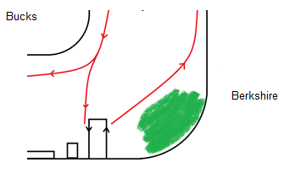
There are 7 recognised turning points (Turning points on the stretch). It is recommended that all crews keep to these turning points to avoid conflict.
Main points:
- Longridge corner. As soon as possible after leaving the landing stage crews must move over to the Berkshire bank, out of the way of all other crews (see diagram above). Crews must not row at firm pressure and should be alert to powered vessels taking the inside of the bend.
- The islands. All crews must use the main channel. Crews should not overtake and keep well into the bank.
- The outlet. The outlet can cause disruption to all crews and will push them into the stream. If travelling side by side crews must take note the effect of the outlet on their course and react accordingly.
- Upper Thames Sailing Club. There are often sailing events being held, which take up the entire width of the river. Crews passing through must obey the ‘wind over manpower’ rule and give priority to all sailing craft. No crew may be at firm pressure when passing through a sailing event, and it is advised they keep close to the bank. The majority of sailing events will occur on a SUNDAY AFTERNOON during the summer term and occupy the stretch of river between The Upper Thames Sailing Club and the Outlet.
- Bourne End Marina. When travelling upstream, all boats should keep vigilant to any cruisers entering or leaving the marina.
- Bourne End Bridge. All crews MUST use the outside arches when going under the bridge and never pass side by side with another boat. Coxes and steerspersons should be aware of the effect of the bridge supports on the river flow and how this will affect their own course. Unless necessary, overtaking should be avoided.
- CookhamBridge. All crews must turn before the bridge.
Powered vessels
Powered vessels should adhere to the rules of navigation however it is not uncommon to come across a powered vessel speeding or on the wrong side of the river or both. Because of this, cruisers should be viewed as a potential hazard, and extremely unpredictable. When confronted with one or more cruisers, coxswains and steerspersons should make their course clear to avoid confusion, and must maintain a steady speed and must not stop directly in the path of a powerboat.
If a powered vessel is behaving in an unsafe manner i.e. speeding or harassing a crew, report it to the Environmental Agency.
Navigation on a strong stream
When the flow rate of the stream is increased (Amber Board) crews must be extra vigilant when completing any manoeuvre, and be aware they must remain apart from other crews.
Coaches will brief crews on the restrictions of that particular outing, and make it clear that the outing may be abandoned at any stage if conditions change of uncertainty is experienced.
Safety Launches
There must be sufficient launch cover for all the crews and the Launch driver must be experienced in capsize rescue and driving in difficult stream conditions.
Boats turning
During turning, all boats have to ensure they are well clear of any obstacles and abide by the circulation pattern of the stretch (see Turning points on the stretch).
Crews should keep considerably further apart from each other than under still water conditions and they should only stop for a considerable time if heading upstream to maintain control of the boat
Turning at Cookham on a strong stream
The stream will push crews towards Cookham bridge, so boats must stop well in advance. If two or more crews are intending to turn they should all stop behind one another and turn one at a time, avoid obstructing another crew.
If a crew plans on remaining stationary for an extended period of time they should do so when facing upstream and well past the corner.
Turning at Bourne End Bridge on a strong stream
Any crew wishing to turn at Bourne End Bridge must pass through the bridge and row towards Cookham. No crew may turn in the immediate vicinity of Bourne End Bridge (as per normal turning rules – Turning points of the stretch) and must ensure that any crew behind them is aware of their intentions.
Night/after dark and rowing in fog
Night/after dark rowing
If any crew intends on rowing after sunset, they must carry appropriate lights on the boat. White lights must be secured to the bow and stern, which are visible throughout 360 degrees, and the crew may wear reflective clothing.
Crews MUST be accompanied by a launch, and the launch must have both a white light and port and starboard markers clearly visible.
No beginner or younger crews may row after dark, and the practice of rowing at night should be discouraged throughout all crews.

Rowing in fog
The minimum visibility required for a session to run in foggy conditions requires the Cardboard Castle to be visible when standing on the end of the pontoons.
If there is fog during an early morning session coaches may take the decision to wait for a period of time to see whether the fog will lift. If the fog does begin to thin, the session will take place, however if not, a decision will be made as to how the session will progress.
Lightning
As a minimum, British Rowing recommends that if a storm is less that 10km away, training must be stopped and appropriate action taken.
It is advised that the ’30-30’ rule be used (count the time between lightning striking and the thunder) and if it is less than 30 seconds, seek proper shelter. If thunder can be heard, but no lightning visible it should be assumed that the storm is within a close vicinity and action taken.
As this is a high risk situation, crews must be taken back to land and made to wait in a proper and safe shelter. There must be a minimum of 30 minutes passed after the last lightning or thunder is seen/heard before leaving the shelter.
As a typical storm moves at about 40km/h, there is approximately 15 minutes to seek ‘proper shelter’. Although no place is absolutely safe from lightning, some are safer than others.
‘Proper’ shelter can be:
- An enclosed substantial building with electric and telephone wiring and plumbing to provide a safe pathway for the current to earth to the ground
- A fully enclosed metal vehicle with windows shut. This acts as a Faraday cage and guides the lightning around the passengers
Unsafe locations and situations are:
- Open spaces (field, lake, river)
- Underneath canopies, small rain shelters, trees, umbrellas, tents and marquees
- Close vicinity to the tallest structure in an area
- Near metal or carbon objects – riggers, boats or blades, trailers or launches
- Using electrical appliances or plumbing such as water taps or sinks

Risk assessment for Longridge and the river
Risk assessment for Longridge and The River
Racing
If a rower is unavailable for an event mentioned on the training plan they must let all members of the coaching team know as soon as possible. It is assumed that everyone is available unless told otherwise.
It is the athlete’s responsibility to ensure they are fully prepared for any event in which they have been entered and they must organise their own transport. Coaches will be in charge of the preparation of equipment for the day and will look after crews once they have been signed in.
Signing in and out
On the day of the race, rowers must be signed in and out be their responsible adult, who will leave an emergency contact number. Once signed in, the rower is then under the charge of the coaches present until they are signed out.
Role of the parent rep
The parent rep at each race event has a primary responsibility to ensure that everyone is signed in and out at the appropriate time. The Parent Rep will also be in charge of the Rowing Phone, so can be contacted regarding lateness or directions. All coaching and rowing matters must still be directed to the Coaches at the event.
Rules of racing
British Rowing rules of racing
Map of the river
Main points of interest
The home stretch of river for Great Marlow School Boat Club is between Marlow Lock and Cookham Lock.
Rescue/access points
In the event of an incident or capsize occurring during a river outing, depending on the severity of injury there is the option of two drop off points.
At full speed a coaching launch can cover the distance from Cookham Sailing Club to Longridge in 25 minutes when carrying one passenger.

Longridge Watersports Centre
Longridge is the main access point for activities conducted on the stretch. Only under extreme circumstances should any other location be considered (Upper Thames Sailing Club – see below). As detailed on the Safety Noticeboard (Safety procedures for the river). If an ambulance is required then they should be directed to the second car park.
Address:
Longridge
Quarry Wood Road
Marlow
Bucks
SL7 1RE
033 0303 0101
Upper Thames Sailing Club
If an incident occurs between Bourne end and Cookham, and the severity of the incident requires it, coaches are advised to consider using Upper Thames Sailing Club as an access point. This is the only point of access for ambulances between Cookham Lock and Longridge,
Address:
Upper Thames Sailing Club
Riverside
Bourne End
Bucks
SL8 5RF
(Use SL8 5PT for SatNavs to avoid ending up in the Marina)

Turning points on the stretch
These are the recommended and official turning points on the river. They have been selected and approved by both Great Marlow School Boat Club and Borlase Boat Club, and are to be used in both normal and a strong stream.
1. Marlow Lock (heading upstream)

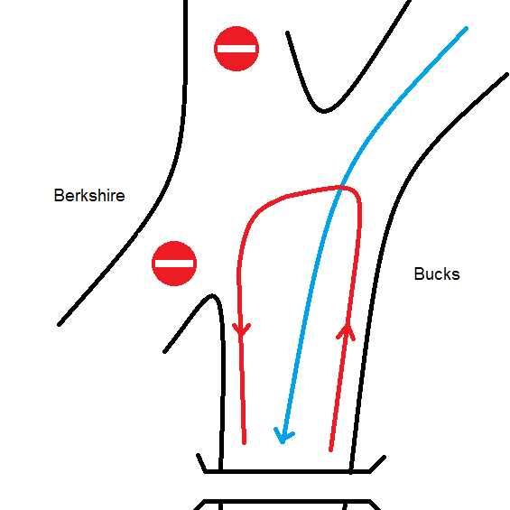
Normal stream
Crews wishing to head towards Marlow Lock should turn just after the split in the stream to maximise visibility. Before turning crews should tuck into the Bucks bank, and turn with a wide arc
Be vigilant for pleasure cruisers, many of which will travel down the centre of the channel who are unaware crews will be turning.

Strong stream
The current will cause turbulence in this section of river due to the weir and the lock. This area should be avoided by inexperienced crews, they should turn at the Cardboard Castle. Ensure that crews are aware of the stronger current towards the Berkshire bank, which will push them round. Also be cautious of the trees along that bank and the risk of getting stuck.
2. Cardboard Castle (heading downstream)

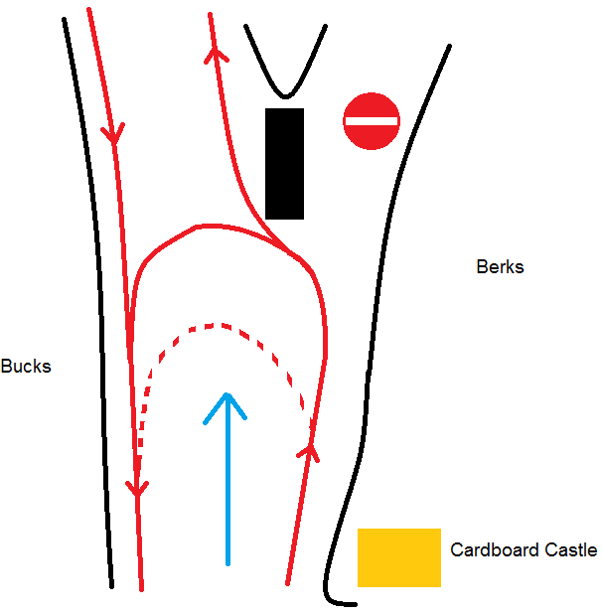
This is for any crews heading downstream wishing to turn back towards the landing stage, before entering the Islands channel. No crew may turn before the Cardboard Castle, or on the corner.
Normal stream
Crews may turn at any point between the Cardboard Castle and the Islands, as long as this does not obstruct any other crews. Their turn must be a wide arc and take them from the Berkshire Bank over to the Bucks bank.
There may be crews travelling at firm pressure between the Islands and the Cardboard Castle, so vigilance is required, especially with more inexperienced participants.
Strong stream
A strong stream will push crews towards the split in the stream and the moored boats. This means crews must easy at least 100m before the moored boats and ensure they are turning in a positive fashion without hesitation. If they wish to easy this must be done after the turn.
3. Cardboard Castle (heading upstream)

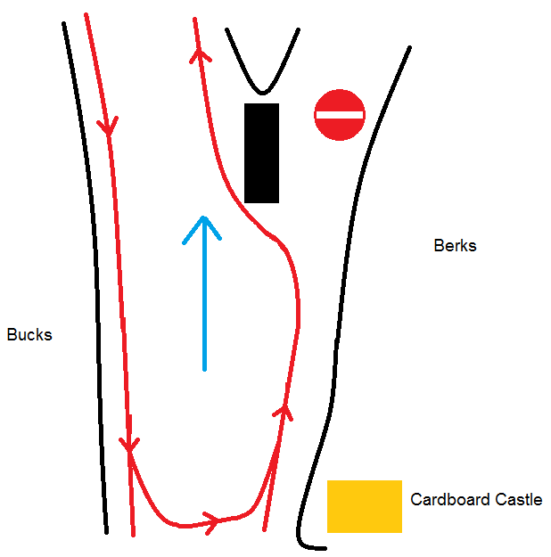
Only to be done when heading upstream along the Bucks bank.
Normal stream
The turn must be completed before passing the Cardboard Castle, as crews may be leaving the landing stage and could cause conflict. Participants must be aware of boating crews, any river traffic coming round the corner and crews doing pieces down the straight. The turn must be wide to ensure that boats remain on the correct side of the river at all times.

Strong stream
On a strong stream the current flow will be very fast down the centre of the stream as the channel is narrowed here. Crews should be aware of this and turn carefully, avoiding getting too close to either bank.
4. Downstream side of the Islands (heading upstream)

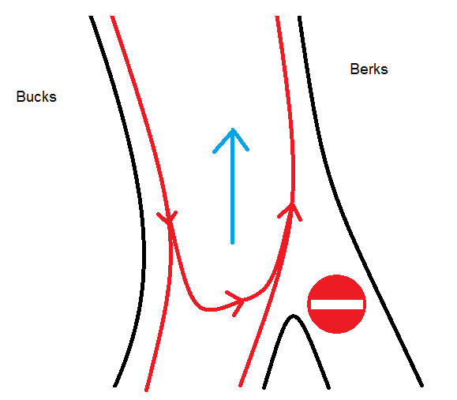
Normal stream
The turn must be completed before entering the outflow of stream from the islands. After turning tuck well into the Berkshire bank to avoid obstructing crews coming through the Islands.

Strong stream
A faster flow rate will push the fastest section of channel towards the Berkshire Bank, which will affect crews turning.
- Upper Thames Sailing Club (heading downstream)
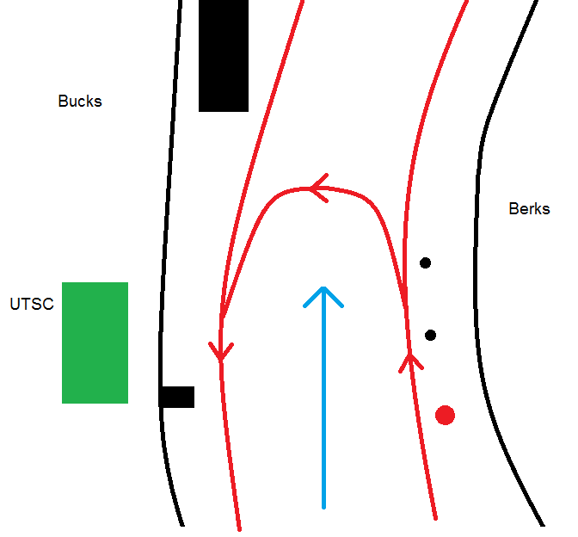
Normal stream
The turn will be completed by crews heading downstream towards Bourne End Bridge. They must stop alongside the buoyed area and begin to turn before entering the marina. Whilst turning, crews should ensure they move over onto the correct side, and avoid blocking the centre channel.
If there is a sailing event occurring, no crews may turn at this point and should instead move down to Bourne End Bridge.

Strong stream
When the current is fast crews should begin to turn before the buoyed area and keep an eye out for other craft on the river. Once turned, crews should paddle upstream before pausing to avoid being pushed into moored boats in the marina.

6.Bourne End Bridge (heading downstream)
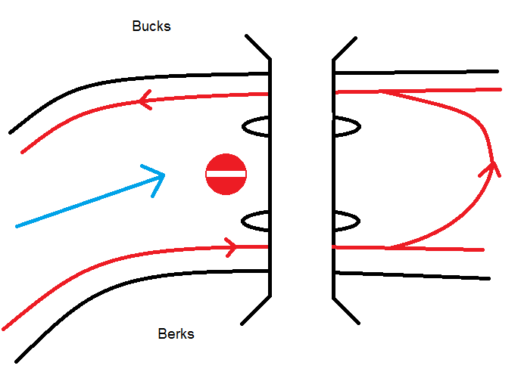
Normal stream
No crew may turn in the upstream area of Bourne End Bridge. They must pass though the outside arch, and turn after the bridge. Crews should be aware of other crews turning from the upstream direction

7.Bourne End Bridge (heading upstream)

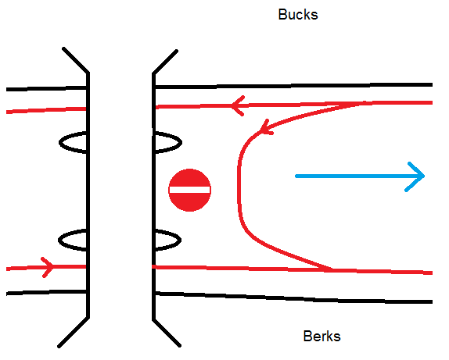
Normal steam
When turning at this point on a normal stream, care must be taken to not obstruct the path of any crews heading downstream. The turn should not occur within 50 metres of the bridge and must take crews from the Berkshire bank to the Bucks bank.

Strong stream
Just be aware that a stronger stream will increase current flow through the bridge and could potentially cause some turbulence. Crews heading from Bourne End downstream will need more stopping distance, so any crews attempting to turn here should ensure the river is clear.
8.Cookham Sailing Club (heading downstream)
Normal stream
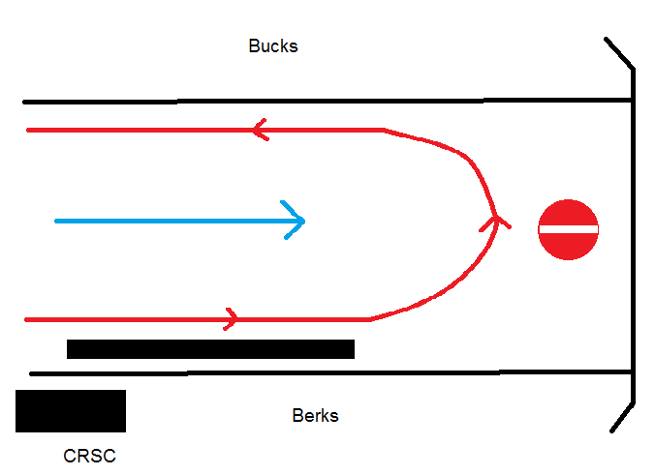
Crews must never pass through Cookham Bridge under any circumstances. When turning at Cookham, they should stop before the moored boats on the Bucks bank and turn immediately, to avoid drifting onto the Bridge. The turn should be wide and take boats from one bank to the other. Vigilance is required as there are often large numbers of pleasure cruisers moving from Cookham Lock, not necessarily on the correct side of the river.

